Red Giant Evolution

This project concerns itself with the investigating the abundance of helium within red giant stars. However, the internal composition of these types of stars is not homogeneous across a sample of red giants. They may be further classified into separate zones of a typical Hertzsprung-Russell diagram, known as the red giant branch (RGB), asymptotic giant branch (AGB), red clump (RC) and secondary clump (2CL). After a star’s core hydrogen is depleted it becomes a red giant and instead begins to burn hydrogen in a shell surrounding an inert helium core. At this stage these stars ascend the RGB and are most useful to our project. However many red giants can be found in the cool end of the horizontal branch seen in the figure below. These are red clump stars and these have begun helium fusion within their cores following what is known as the helium flash. This is a runaway nuclear fusion event in which large quantities of helium are fused into carbon and occurs in lower-mass stars (0.8-2.0 Mʘ). The asymptotic branch contains red giants that burn helium in a shell surrounding an inert carbon-oxygen core. Beyond this the star’s fusion ends and its core shrinks and the surrounding gases are ejected to become a nebula.

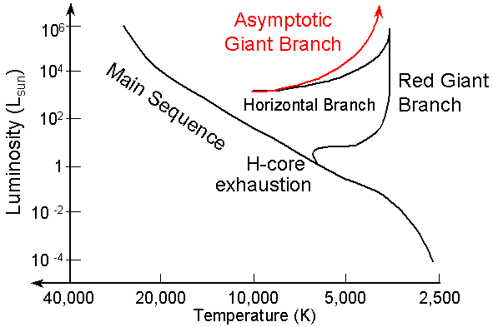

From classical observations of stars (spectroscopic), it can often be impossible to distinguish between red giants burning hydrogen in a shell around an inert helium core (RGB) and core-Helium burning stars of similar radii (10-12 Rʘ). This is due to these stars having similar surface characteristics such as temperature, surface gravity and luminosity.

Asteroseismology is a modern technique which can be used to determine the stellar evolution of these red giants. For example Kallinger et al. (2012) concentrated on the l = 0 radial modes. They demonstrated that a determination of ∆ν based only on a few modes around νmax gives rise to a locally defined ɛ; the offset in the asymptotic approximation, such as the one we have employed from Vrard et al. (2014). This asymptotic offset carries a signature of the evolutionary state of the star.

Y Elsworth et al. (2016) suggest that the only valid classification for a red giant existing on the RGB is if νmax is below 12 µHz or above 125 µHz. This is touted as a robust and efficient method of identification and has been performed on over 6000 APOKASC red giants. This can be found on the project’s one drive for classification of our dataset.